**SQL Assignment**

**1**

1. Display the toys which are available for the rent (Simple select)

SELECT Toy_name FROM Toy;

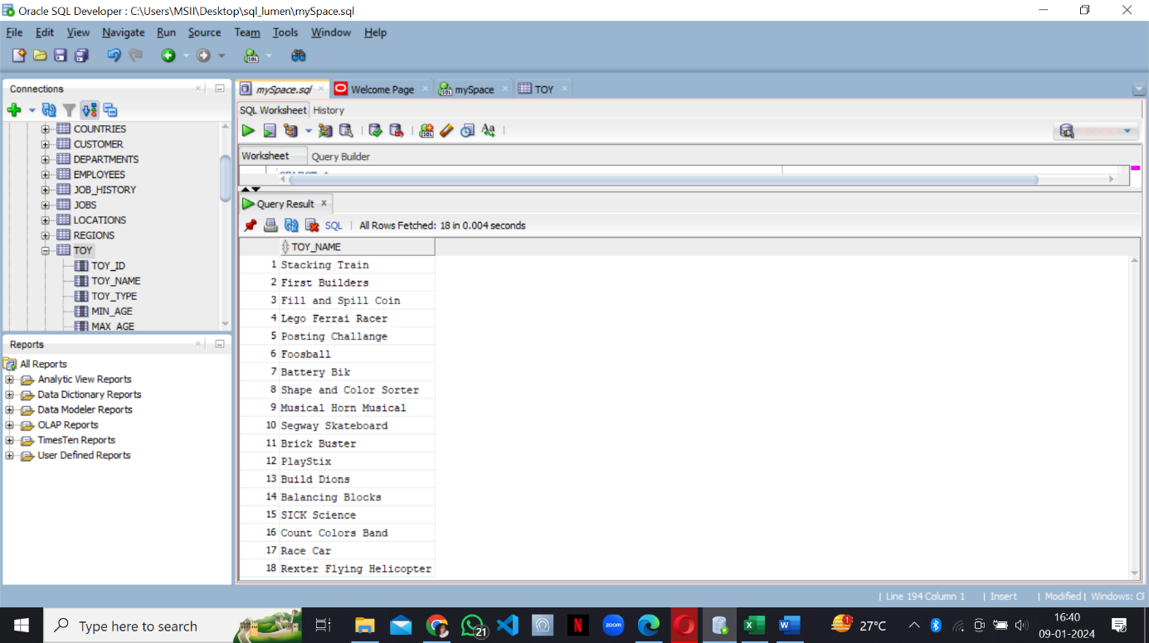

1. Display all the toys for the age group Simple select with where clause

SELECt toy_id,toy_name FROM Toy WHERE min_age>=2 AND max_age <=12;

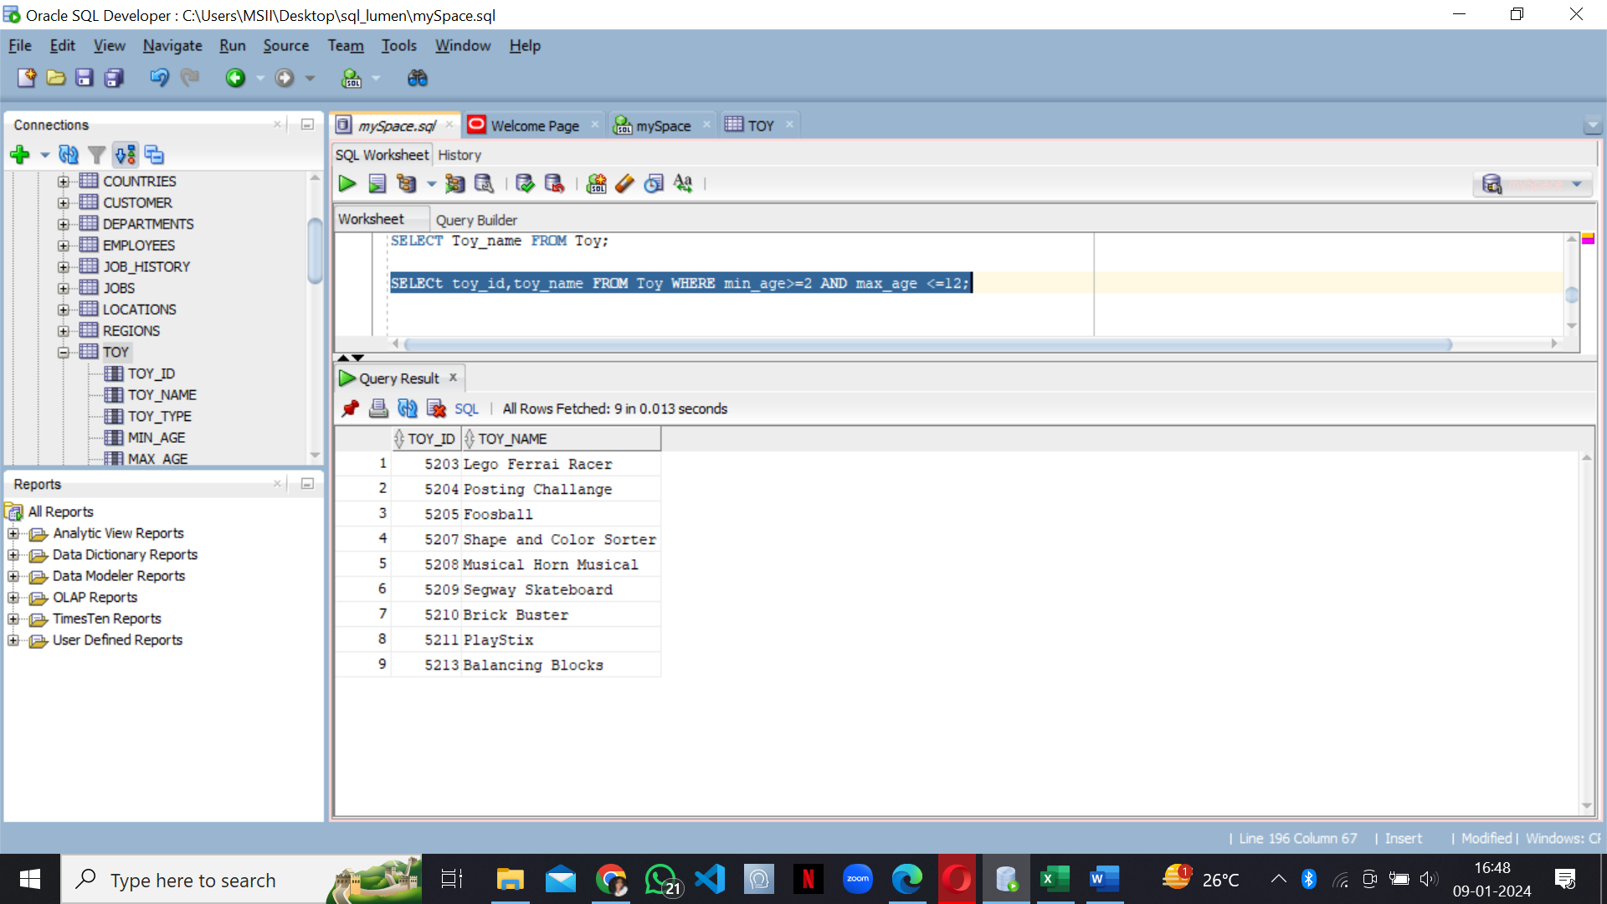

1. Display the toys which have a price more than $145 and the quantity is 5 Simple select with and Operator

SELECT TOY_NAME, PRICE, QUANTITY FROM TOY

WHERE PRICE >145 AND QUANTITY = 5;

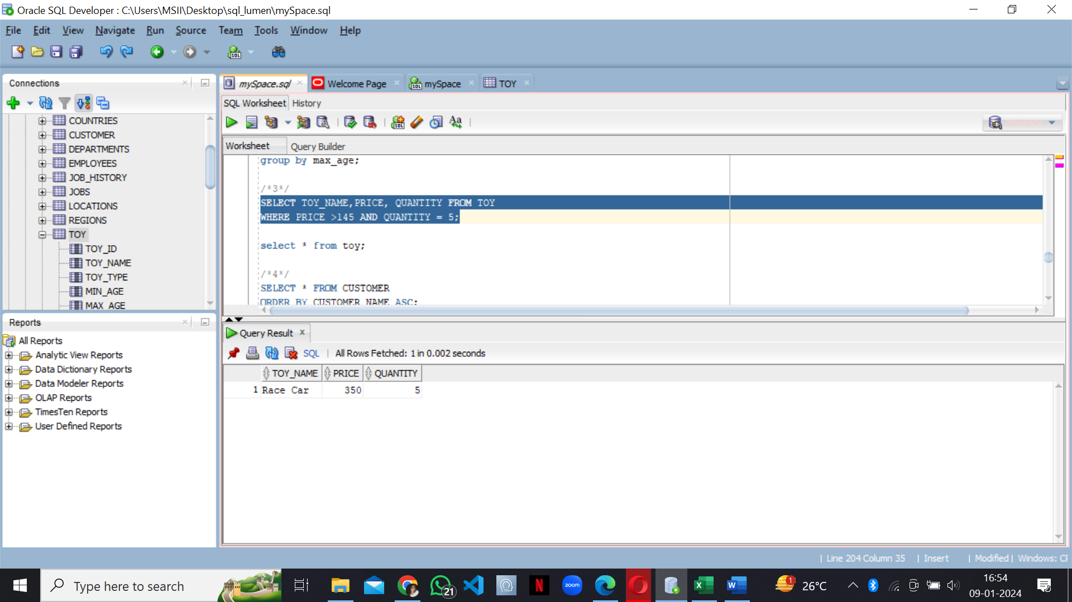

1. Display the customers in the ascending order (alphabetically by their name)

SELECT CUSTOMER_NAME FROM CUSTOMER

ORDER BY CUSTOMER_NAME ASC;

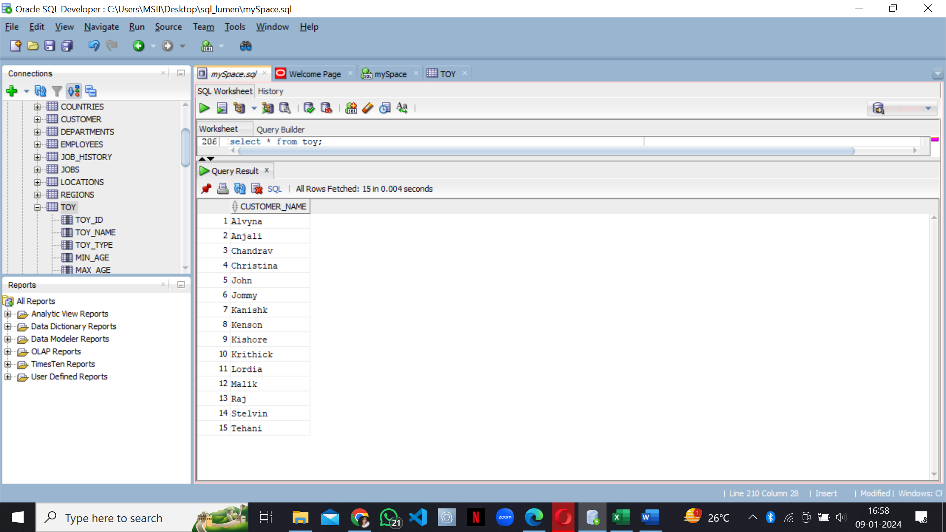

**2**

1. Display the Customer Count Based on the City Simple select with count

SELECT CITY, COUNT(CUSTOMER_ID) AS COUNT_OF_CUSTOMER

FROM Customer

GROUP BY CITY;

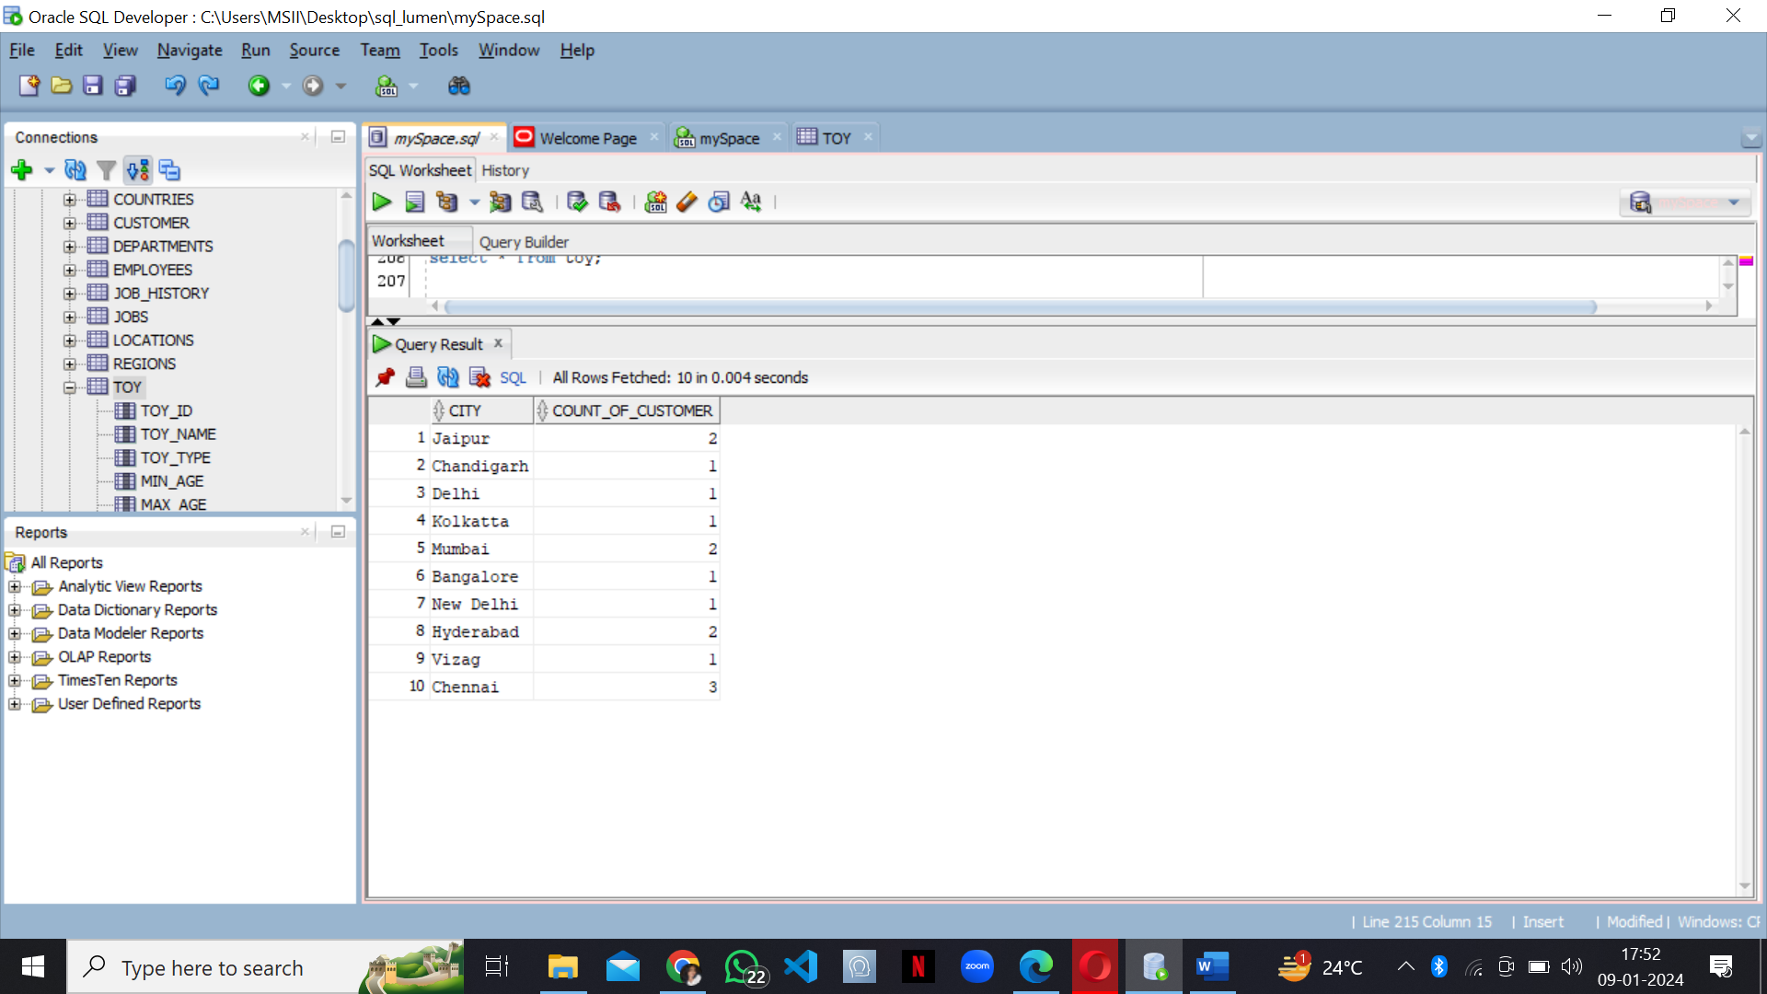

1. Display the customer who has availed rental more than two toys currently Use inner join

SELECT CUSTOMER.CUSTOMER_NAME,COUNT(*) AS NO_OF_TOYS

FROM TOY_RENTAL

INNER JOIN CUSTOMER ON

CUSTOMER.CUSTOMER_ID=TOY_RENTAL.CUSTOMER_ID

GROUP BY CUSTOMER.CUSTOMER_NAME

HAVING COUNT(CUSTOMER.CUSTOMER_NAME)>2;

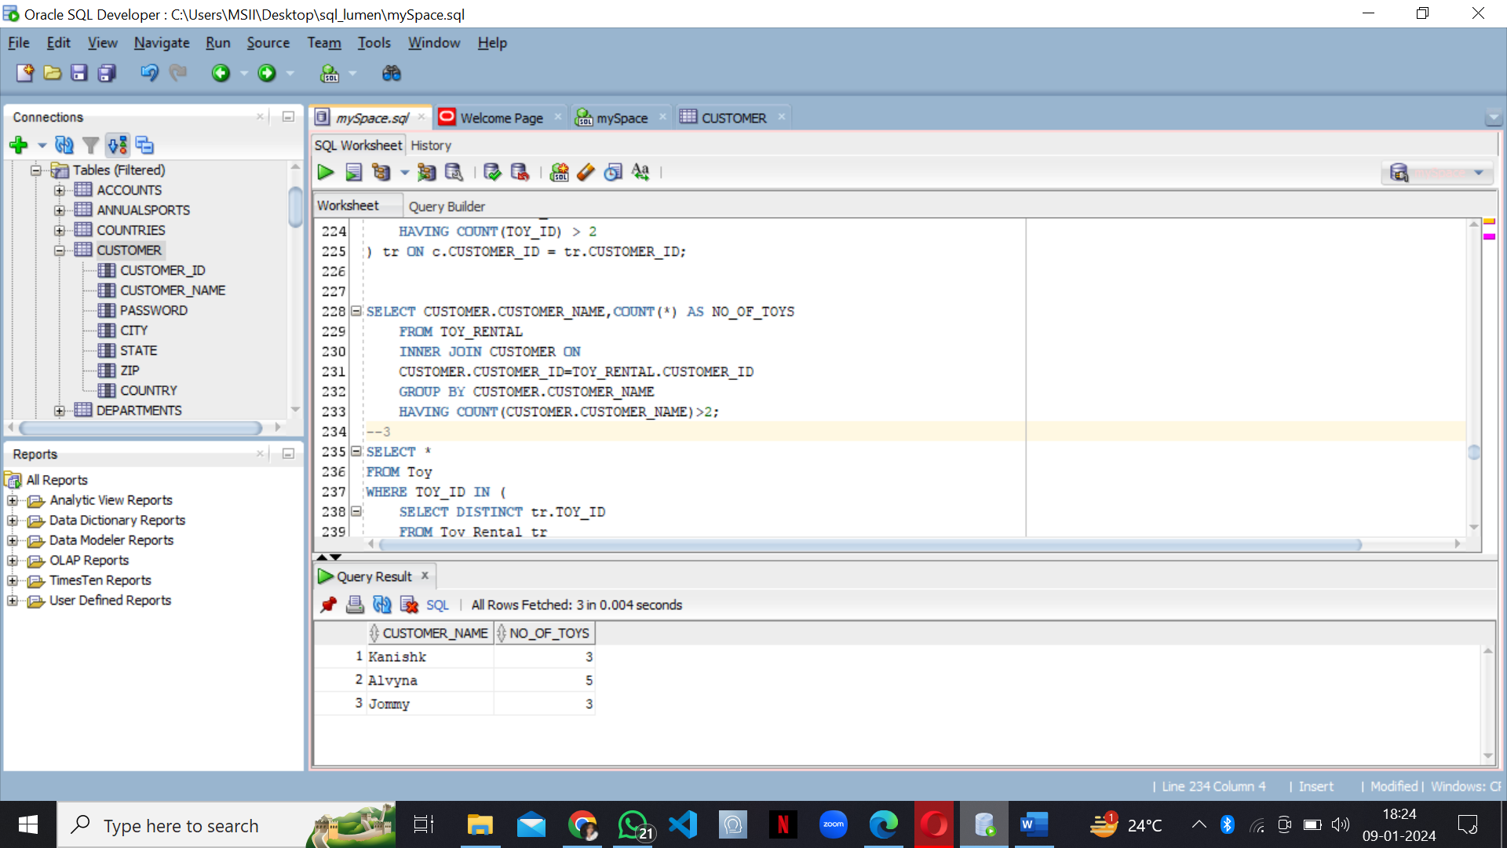

1. Display the toys which were taken for rent only in “Bangalore” Use Subquery

SELECT TOY_ID,CUSTOMER.CUSTOMER_NAME,CUSTOMER.CITY

FROM TOY_RENTAL

INNER JOIN CUSTOMER ON

CUSTOMER.CUSTOMER_ID=TOY_RENTAL.CUSTOMER_ID

WHERE CUSTOMER.CITY='Bangalore';

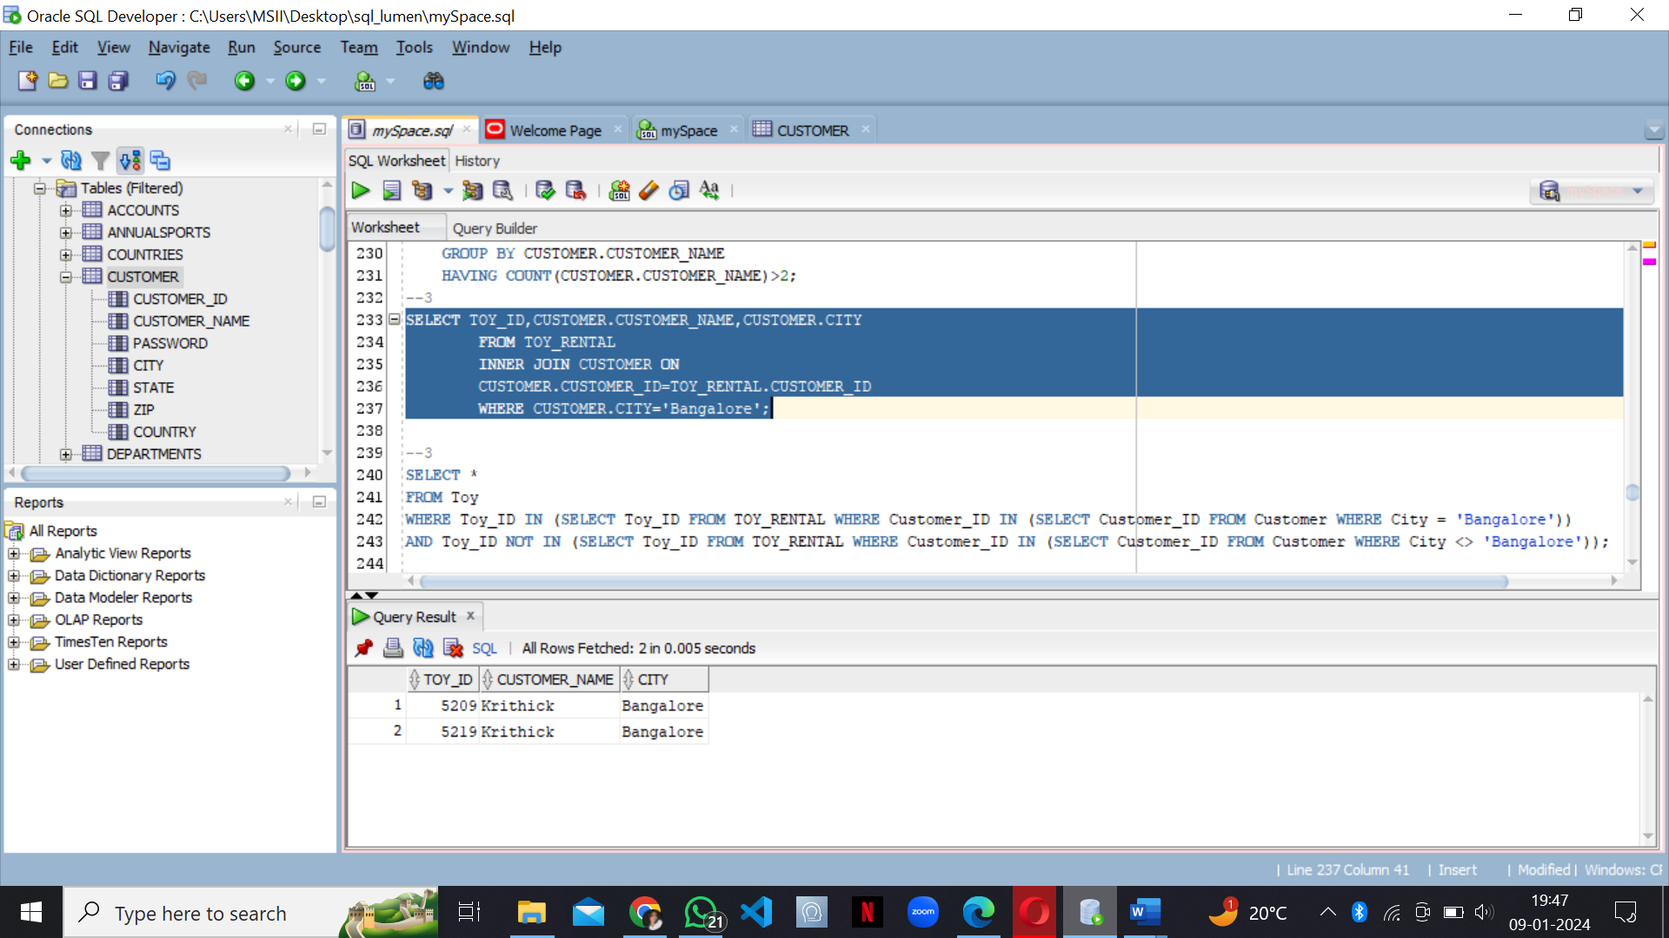

**3**

1. Display the toys which was not at all rented out and display toy names in the ascending order of the toy names

SELECT TOY.TOY_NAME FROM TOY_RENTAL

RIGHT JOIN TOY

ON TOY_RENTAL.TOY_ID = TOY.TOY_ID

where TOY_RENTAL.TOY_ID IS NULL

ORDER BY TOY.TOY_NAME ASC;

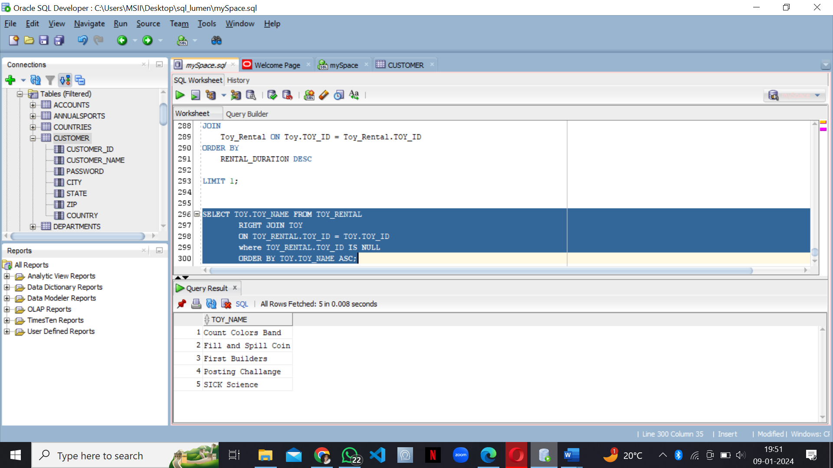

1. Display the toys which was rented out on 20/05/2020 Use inner join

SELECT TOY.TOY_ID,TOY.TOY_NAME FROM TOY_RENTAL

INNER JOIN TOY

ON TOY_RENTAL.TOY_ID = TOY.TOY_ID

where TOY_RENTAL.RENTAL_START_DATE ='20-MAY-20';

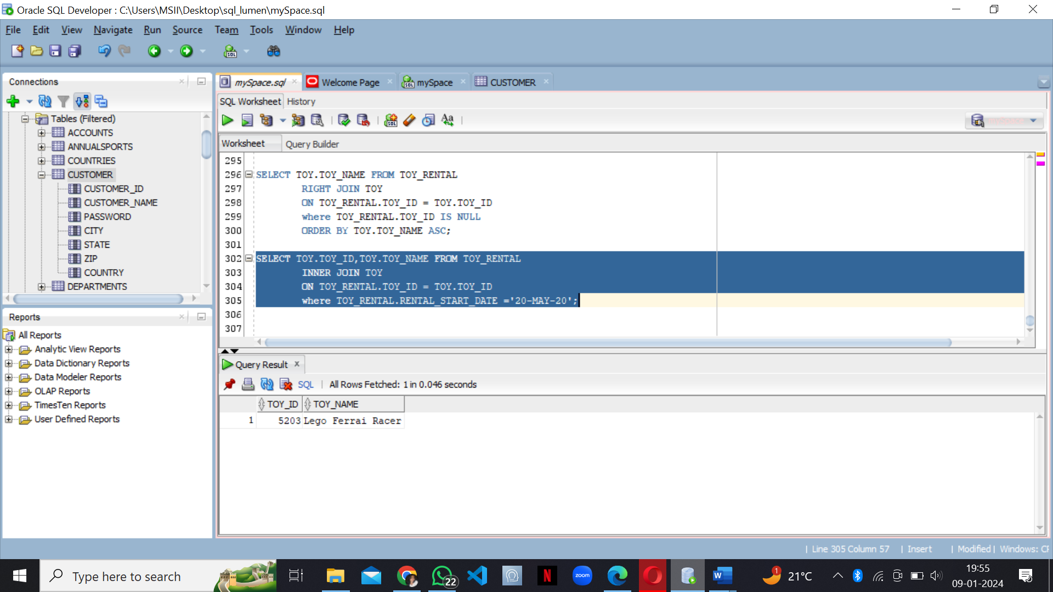

1. Display all the customers with the rental details even if they haven’t availed any toys for rental Use joins and group by

SELECT *

FROM CUSTOMER

FULL OUTER JOIN TOY_RENTAL

ON CUSTOMER.CUSTOMER_ID=TOY_RENTAL.CUSTOMER_ID ;

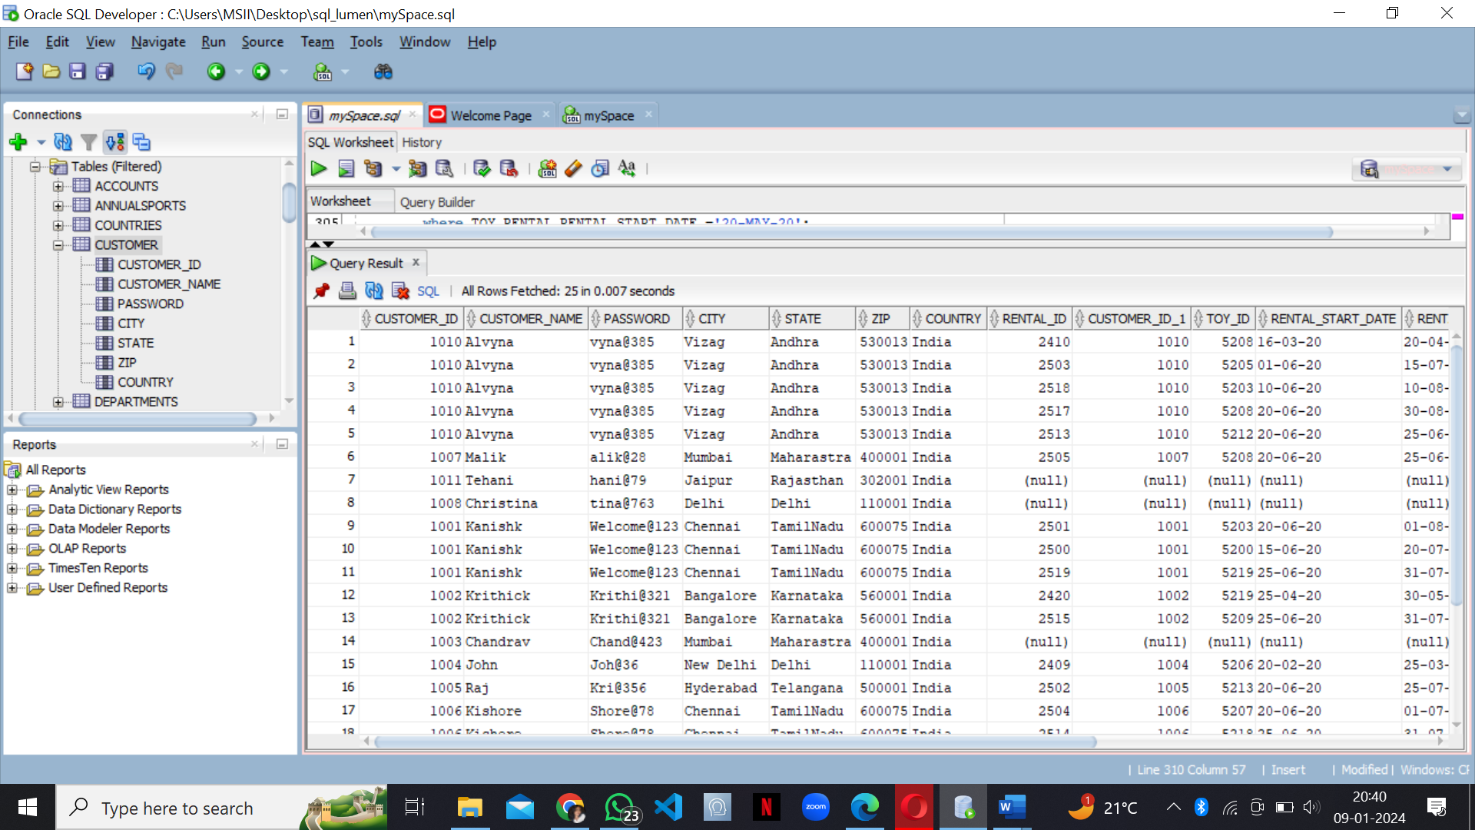

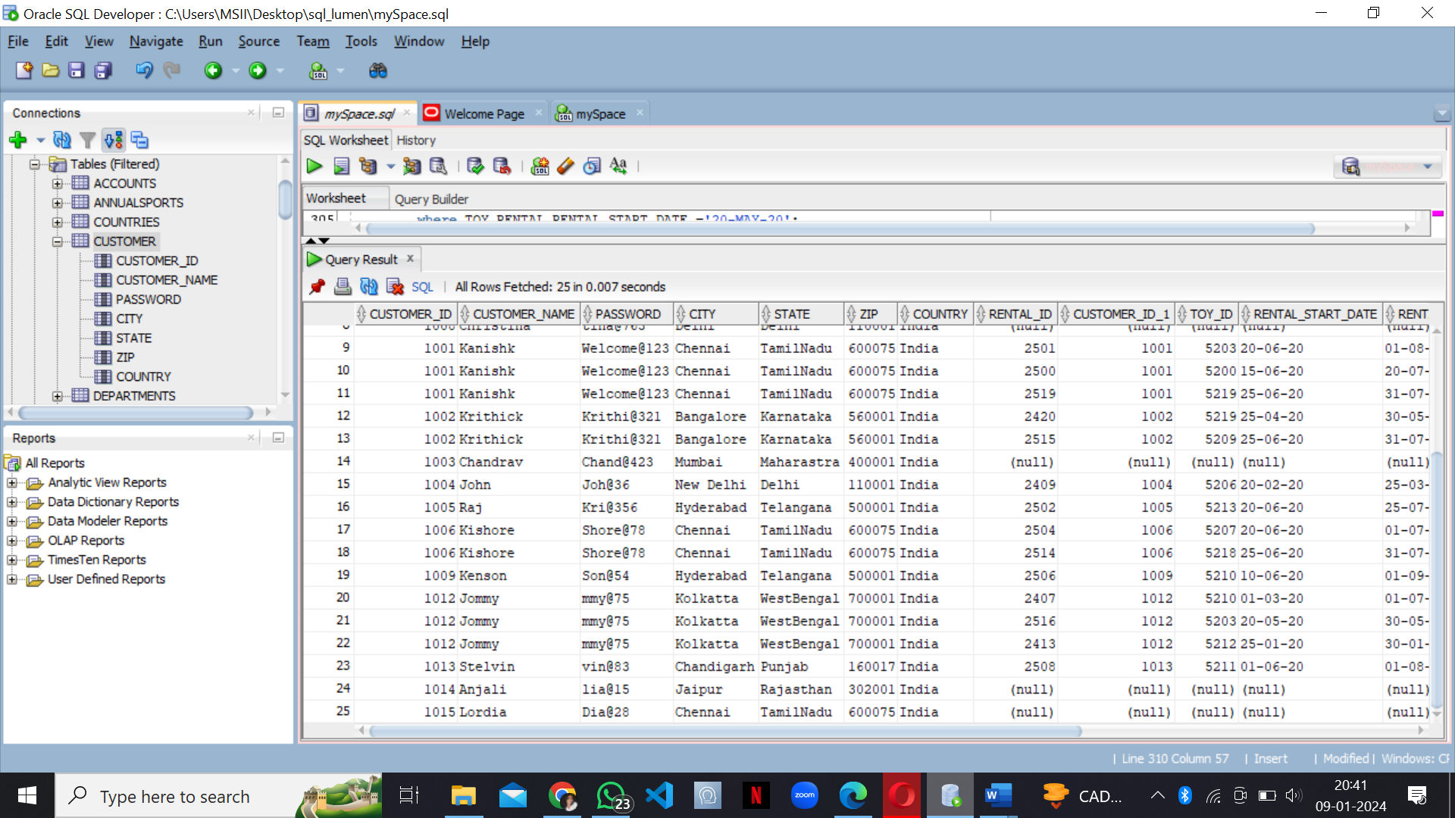

1. Fetch the toys which was on rent for maximum duration. . Use joins

SELECT B.*,A.DAYS FROM

(SELECT TOY_ID,SUM((RENTAL_END_DATE-RENTAL_START_DATE)) AS DAYS

FROM TOY_RENTAL

GROUP BY TOY_ID

ORDER BY SUM((RENTAL_END_DATE-RENTAL_START_DATE)) DESC

FETCH FIRST 1 ROWS ONLY) A

INNER JOIN TOY B

ON A.TOY_ID=B.TOY_ID;

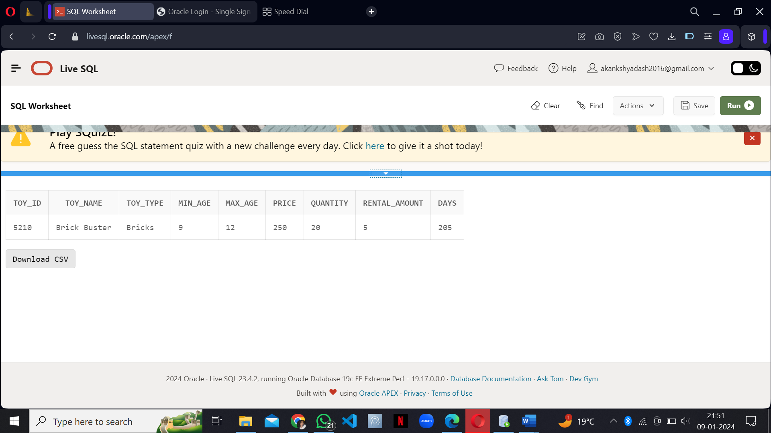

1. Display the customer information and toys information for the rental_id/s which were rented on 25th of Jan 2020 Use joins and date functions

* SELECT C.CUSTOMER_NAME,C.PASSWORD,C.CITY,C.STATE,C.ZIP,C.COUNTRY,D.TOY_ID,D.TOY_NAME FROM
* (SELECT * FROM
* (SELECT * FROM TOY_RENTAL

WHERE RENTAL_START_DATE='25-JAN-20') A

INNER JOIN CUSTOMER B

* ON A.CUSTOMER_ID=B.CUSTOMER_ID) C

INNER JOIN TOY D

ON C.TOY_ID=D.TOY_ID;

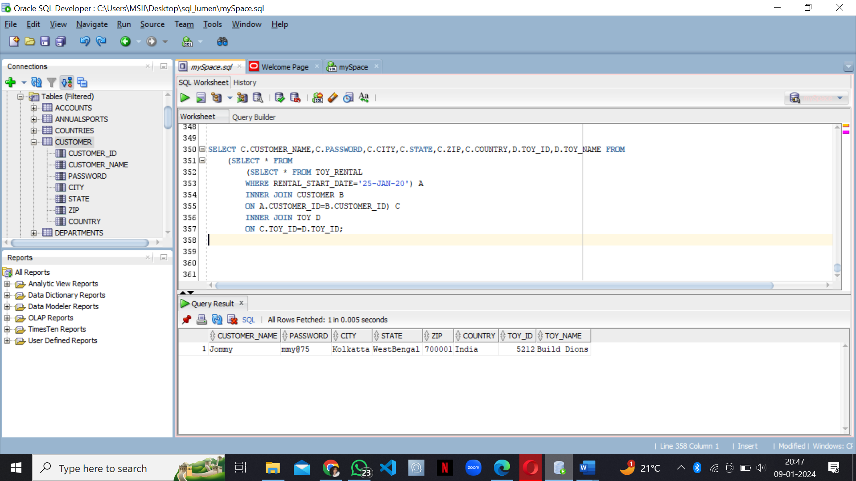

1. Write a query to display customerid,number of toys rented, total net amount paid by each customer.Display above result on the ascending order of customer ids. Use Joins

SELECT CUSTOMER_ID,TOYS_RENTED,TOTAL_AMOUNT_PAID from(

SELECT CUSTOMER_ID,COUNT(CASE WHEN STATUS='Rented' THEN TOY_ID END) AS

TOYS_RENTED,SUM(TOTAL_AMOUNT+COALESCE(FINE,0)) AS TOTAL_AMOUNT_PAID

FROM TOY_RENTAL

GROUP BY CUSTOMER_ID)

WHERE TOYS_RENTED>=1

ORDER BY CUSTOMER_ID;

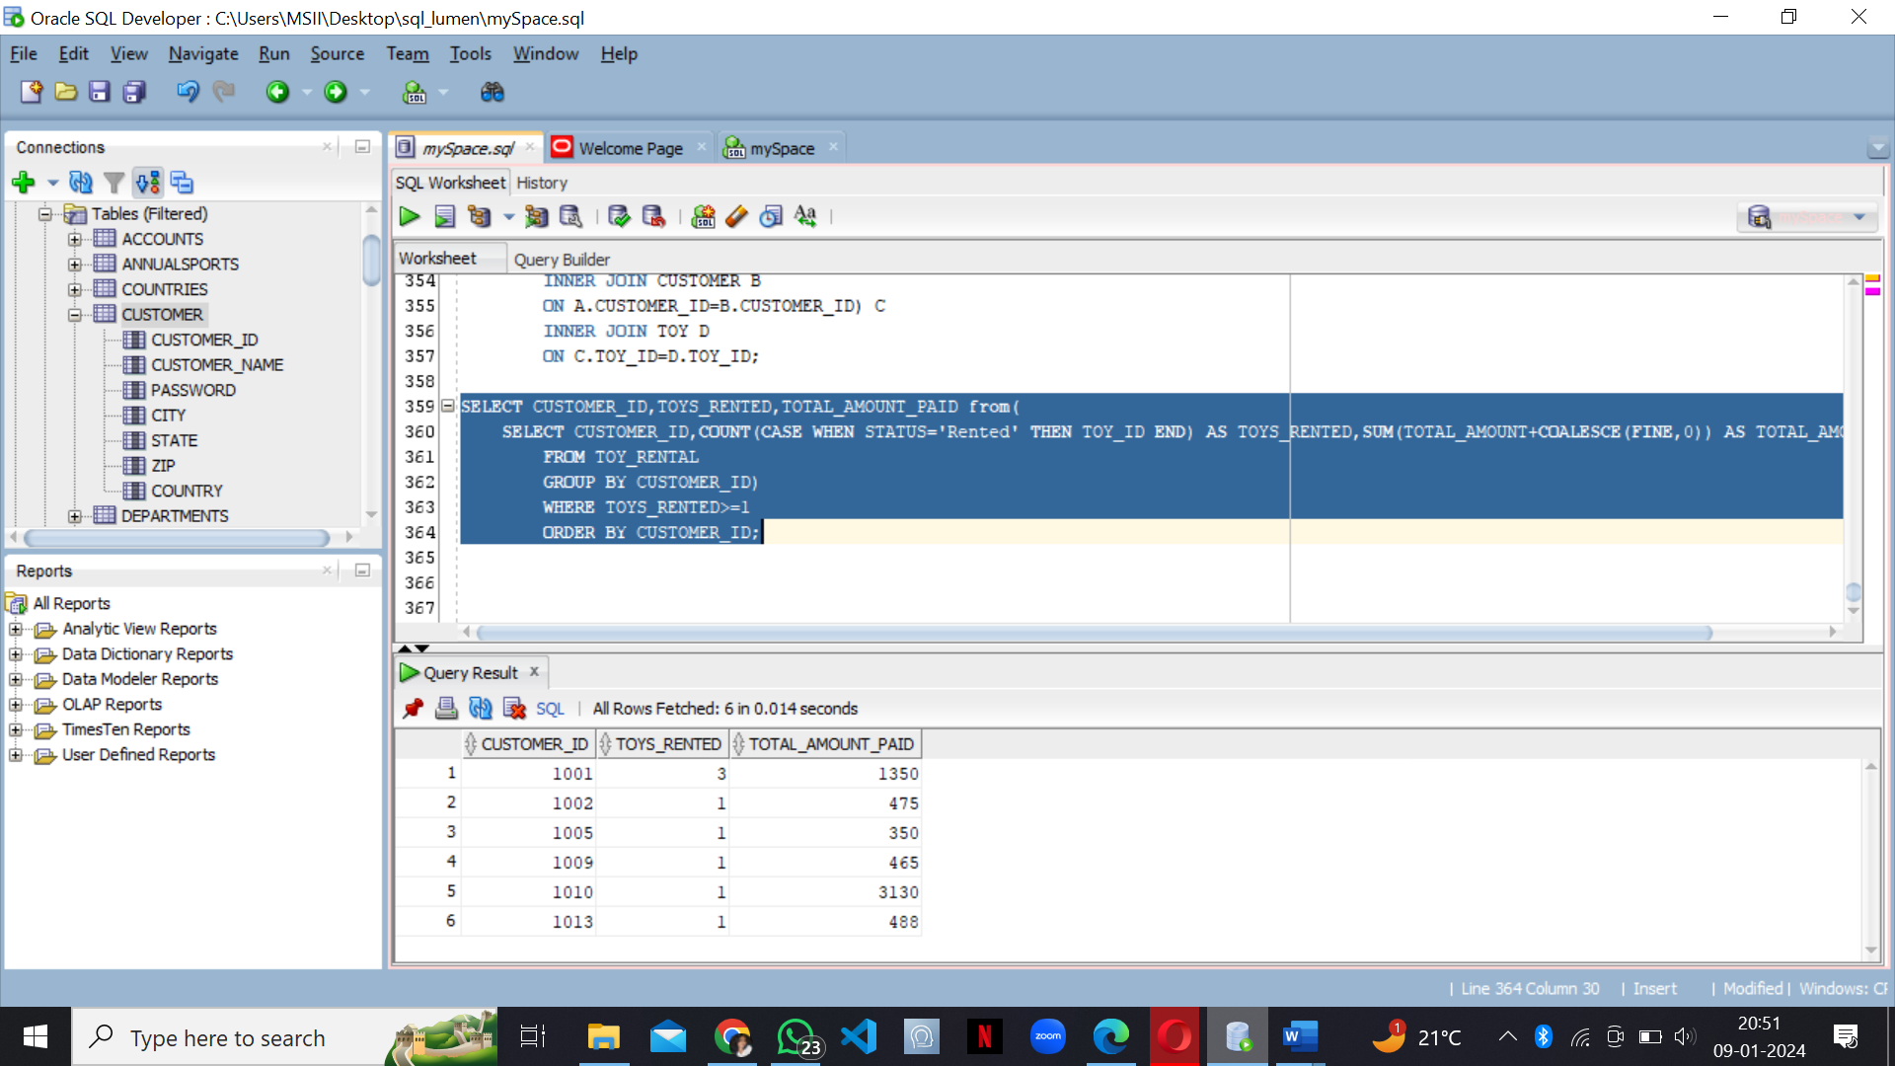

1. Display the Rental details of a customer “John” . Use Subquery

SELECT * FROM TOY_RENTAL

WHERE CUSTOMER_ID =(SELECT CUSTOMER_ID FROM CUSTOMER WHERE CUSTOMER_NAME = 'John');

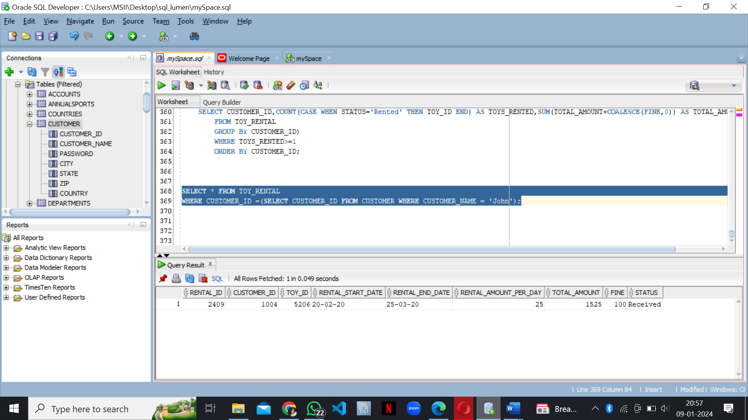

1. Fetch the user information who have not returned the toys after the rental period

SELECT A.* FROM CUSTOMER A

INNER JOIN

(SELECT *FROM TOY_RENTAL

WHERE STATUS='Rented') B

ON A.CUSTOMER_ID=B.CUSTOMER_ID;

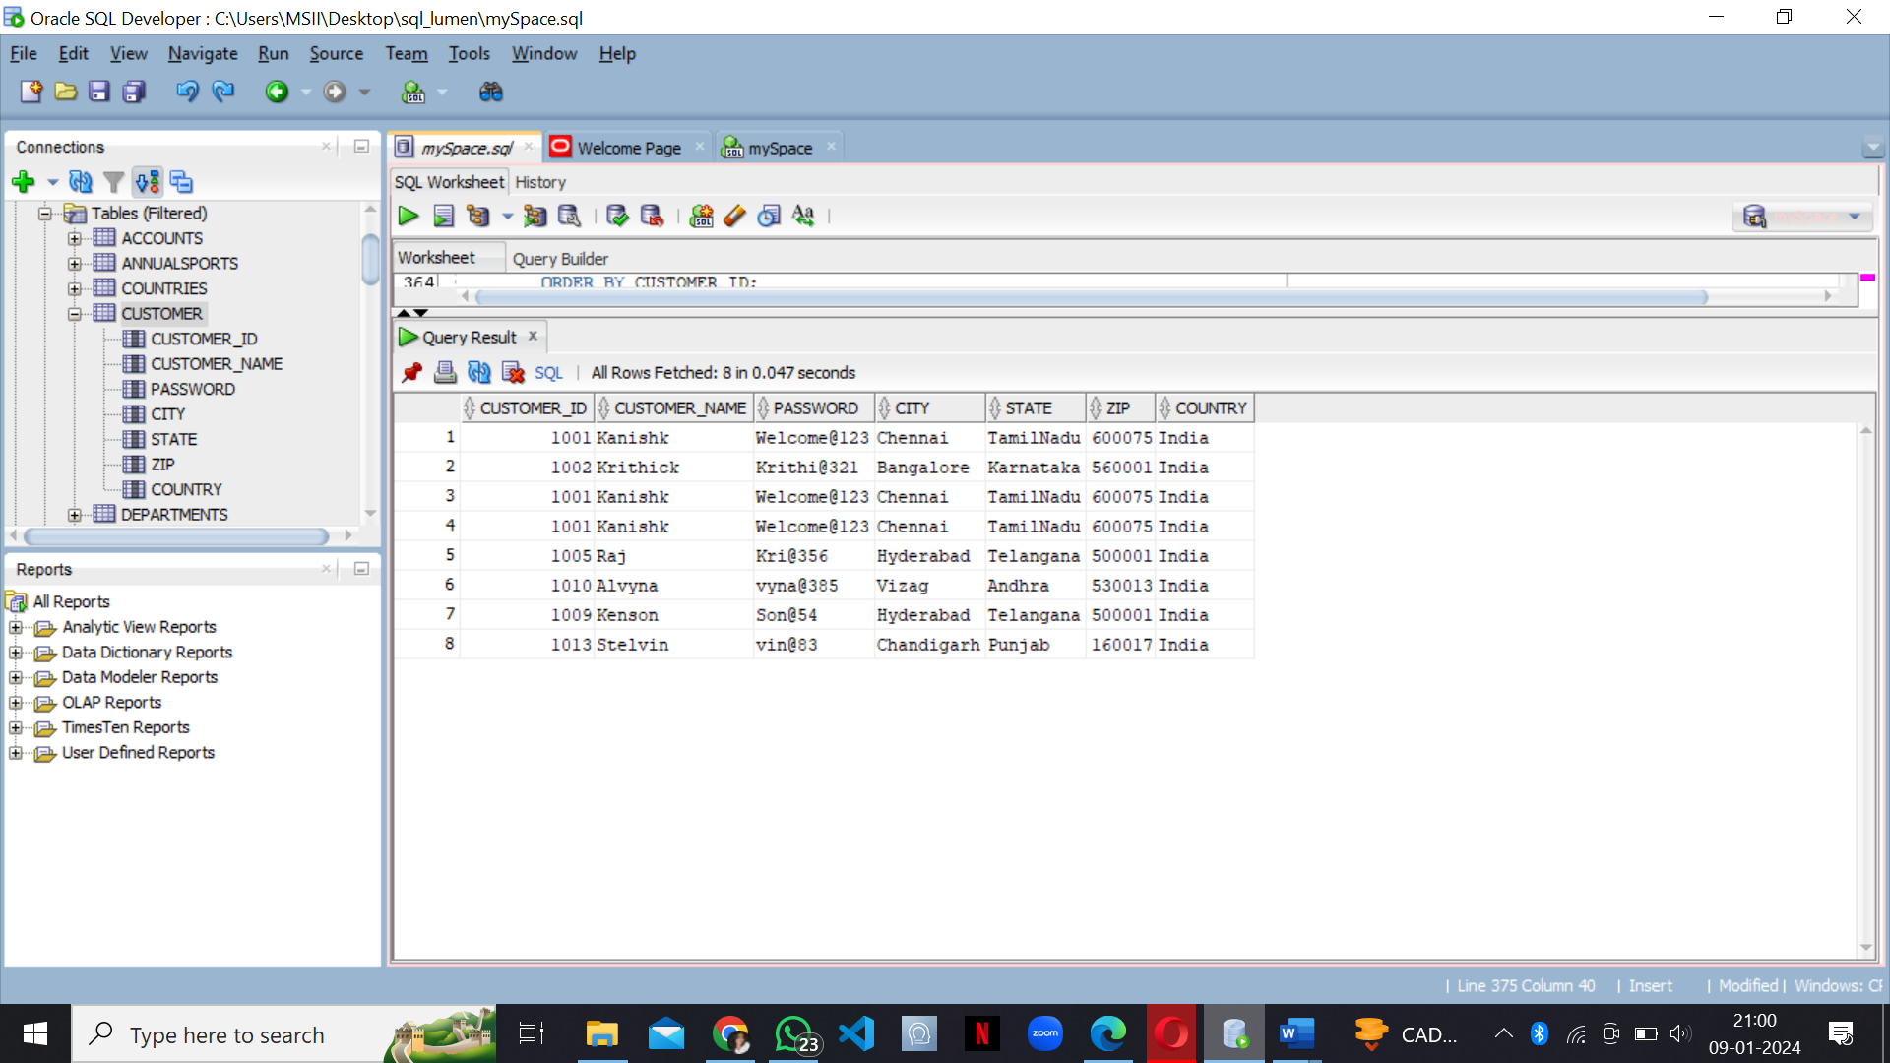

1. Display all the rental details of a toy named PlayStix. Use Subquery

SELECT A.* FROM TOY_RENTAL A

INNER JOIN

(SELECT * FROM TOY

WHERE TOY_NAME='PlayStix') B

ON A.TOY_ID=B.TOY_ID;

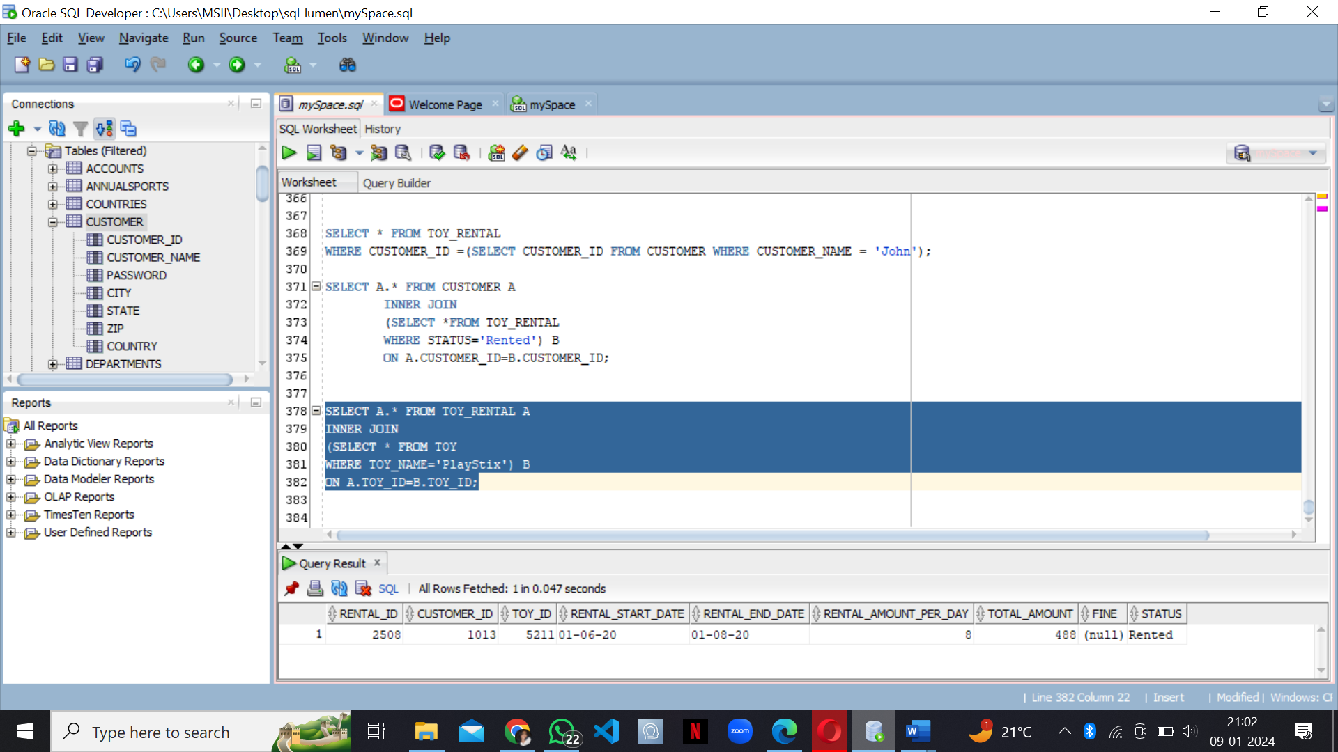

1. Identify the customers who have opted for more than 1 toy for rental . Use join

SELECT CUSTOMER_NAME FROM CUSTOMER A

INNER JOIN

(SELECT CUSTOMER_ID,COUNT(RENTAL_ID) AS NO_OF_TOYS FROM TOY_RENTAL

GROUP BY CUSTOMER_ID) B

ON A.CUSTOMER_ID=B.CUSTOMER_ID

WHERE B.NO_OF_TOYS>1;

